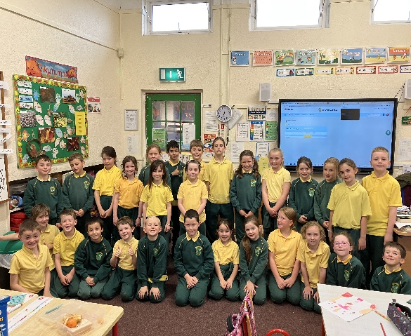

**Maths** 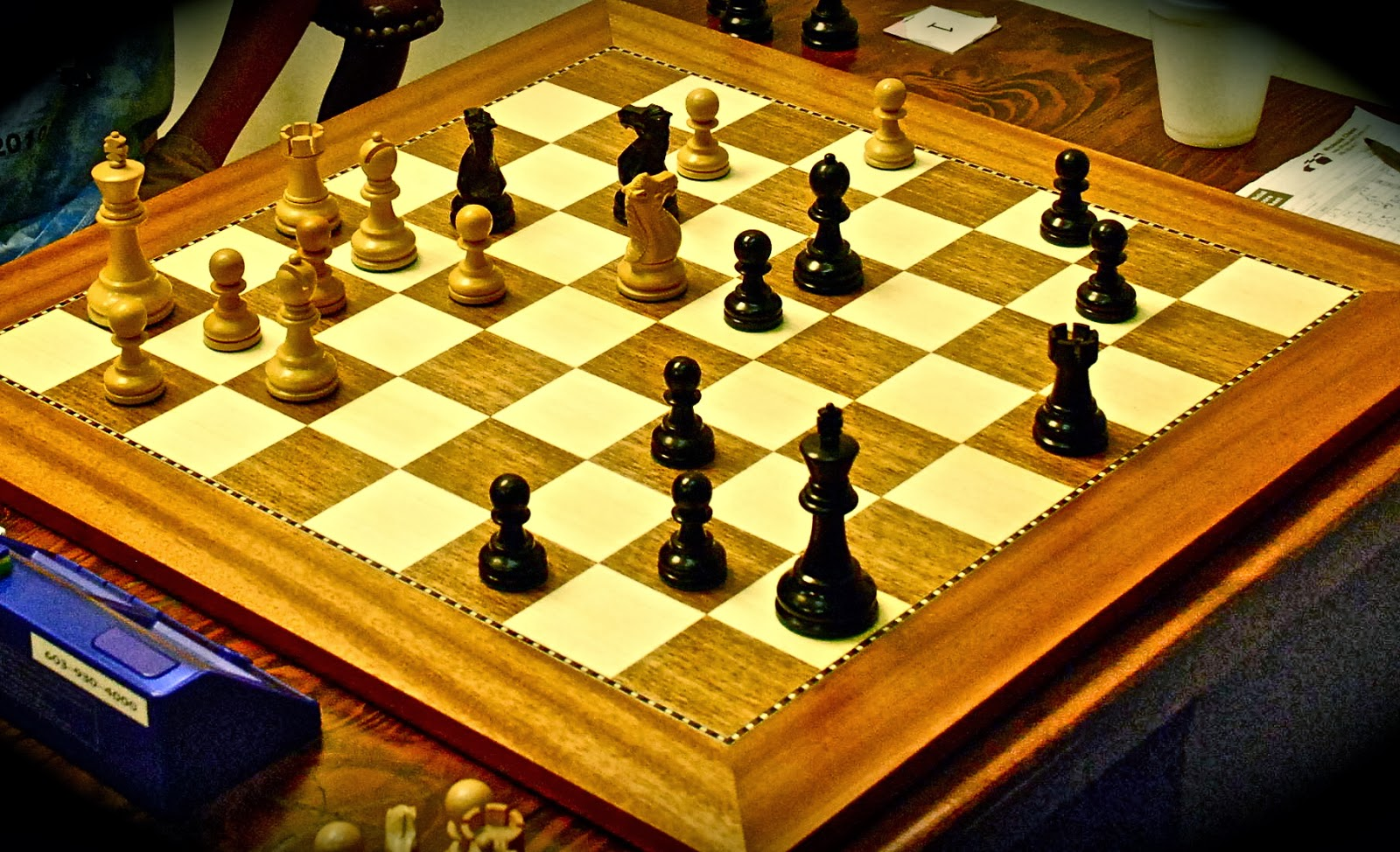

We learned about greater than, less than and equal to and we remember the symbol by the CROCODILES MOUTH. We also learned new maths strategies: doubling and numbers bonds to ten. We played BULLETS, CHESS and CARDS to help us solve problems and remember our strategies. Editors Jude, Charlie, Evan and Noah

**RE** 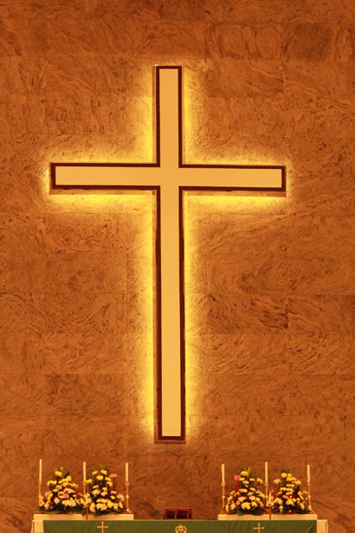

We are learning how to following Jesus and be a good friend. We have listened to stories about Jesus.

**Sport / PE** 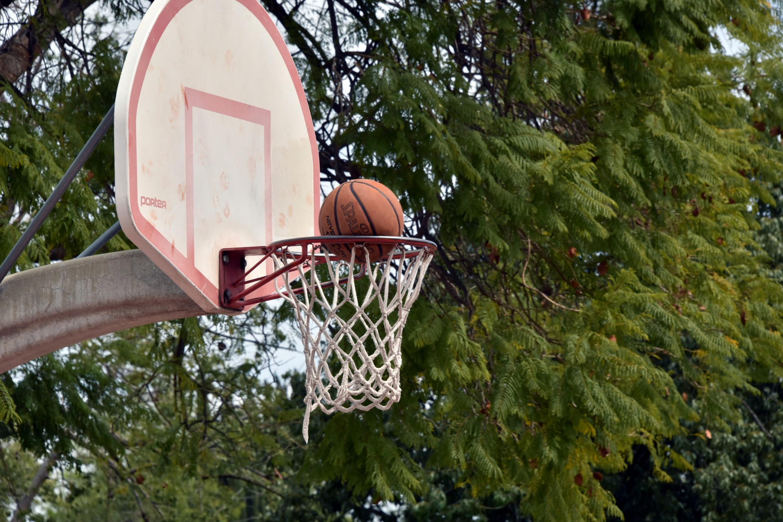

We are learning new skills in Basketball. We are playing Gaelic football with Finn and we had an introduction to rugby. Editors Teddy, Elizabeth, Tom, Layla and Lily

**Visits** 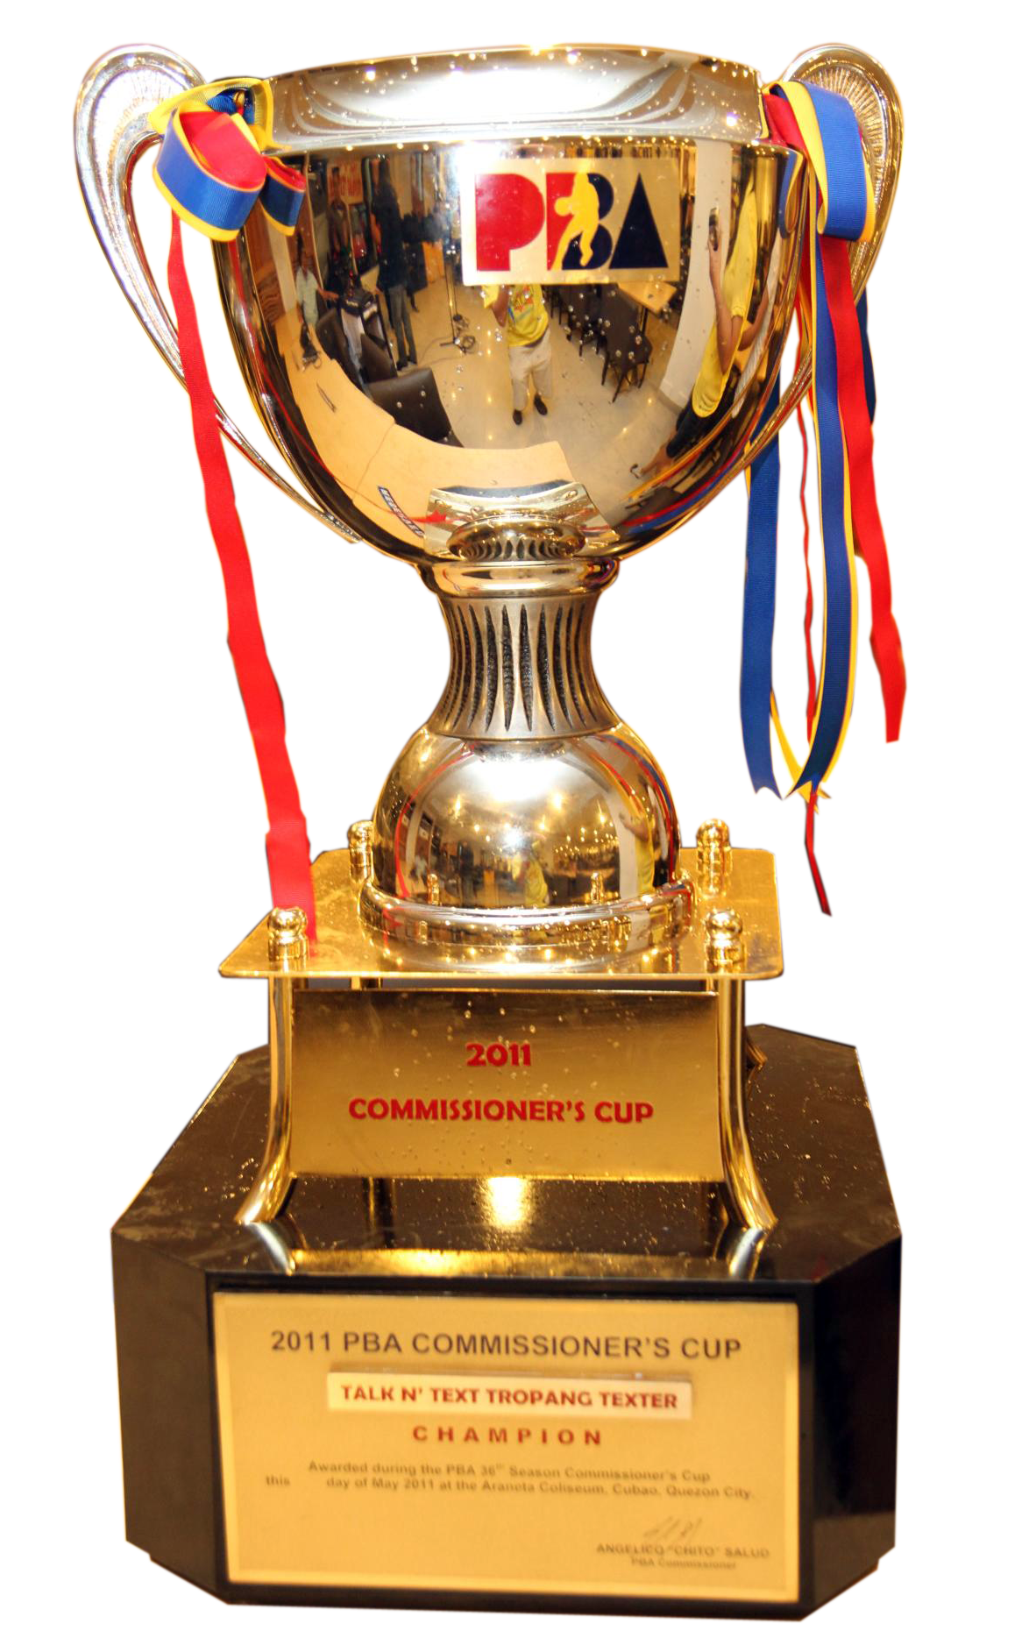

Three ladies from the Meath football team visited our school. They brought the Brendan McCarty Cup.

We visited the church to celebrate being back to school. Editors Joe, Callum, JP and Adam

**Gaeilge**

D’fhoghlaimíomar stór focal agus frásaí bunaithe orm féin agus ar an scoil. Chanamar amhráin agus d’aithris muid dánta. Bhí craic agus ceol againn.

**Specials Days and Birthdays **

We remembered the Ukraine people on World Peace Day by dressing in blue and yellow and by bringing in a euro to help Ukraine charities.

**Nancy, Layla, Ava , Tom O C and Anna** celebrated their birthdays. Editors Luke, Hugo, Ava and Saoirse

**SESE** 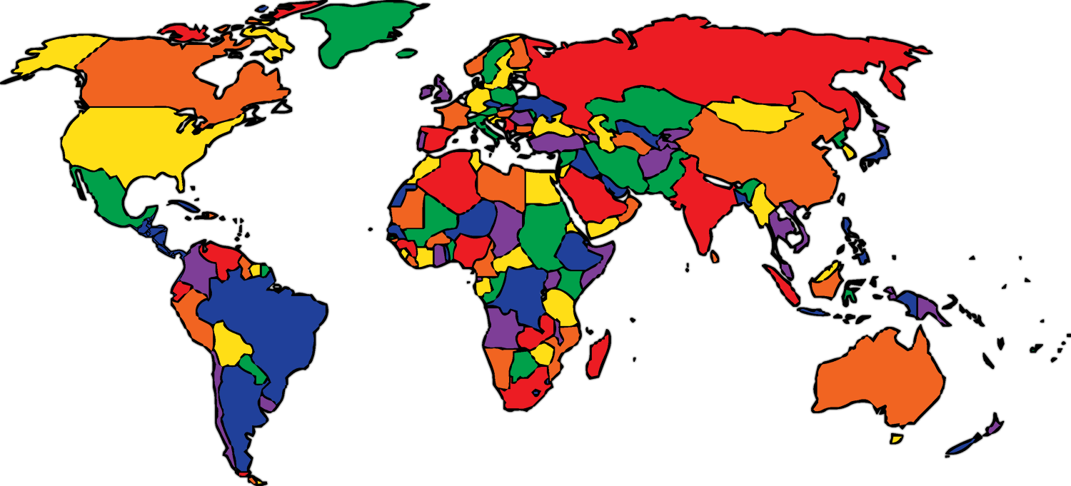

We learned about food from around the world. We are also learning about our locality and to remember our addresses and eircodes. Edited by Tom M, Lauren, Ryan and Anna

**Arts** 

We studied the artist Leonardo Da Vinci and his painting The Mona Lisa - ‘La Joconde’ and we painted our own self -portraits. We began Drama with Suzanne and we learned simple songs and played the chime bars. Editors: Aimee, Elle, Jamie and Isla

**English**

We shared news. We chose new library books. We learned about school days in olden times and wildlife from OTM. We recited poems and we are enjoying listening to our class book Charlie and The Chocolate Factory by Roald Dahl – Editors – Olivia, Orlaith, Sophie and Nancy