St Andrew’s National School

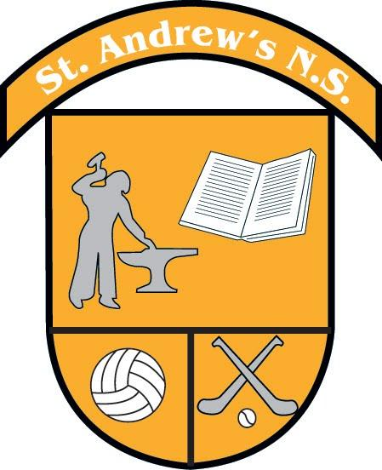
FIRST CLASS BOOK LIST 2022 - 2023
Items which should be purchased and brought to school on Day One
(all other books will be provided through our Book Rental Scheme)

Subject | Book Title(s) | Publisher
English | Mrs. Murphy's 1st Class Copy (Cursive) Mrs Murphy’s 1st Class writing Copy  Over the Moon Skills Book (1st Class)  My Spelling Workbook B | BCM  BCM  Prim Ed
Maths | Busy at Maths 1  Table Toppers 1  New Wave Mental Maths 1st Class | C.J. Fallon  C.J. Fallon  Prim Ed
Gaeilge | Bua na Cainte 2 | Edco
R.E. | Grow in Love 4 (2nd class) | Veritas
S.E.S.E. | Let’s Discover (1st class) | C.J. Fallon
Misc. | 1 x Homework Diary (to be bought from school)  1 x 88 page copy labelled ‘English’  1 x 40 page maths copy (small squares)  1 x small hardback copy labelled ‘Tests’  1 x 24 page A4 scrapbook  2 pencils, 2 red pens, pencil sharpener, eraser, 30cm ruler  Colouring pencils  2 glue sticks
Uniform | Blue shirt Maroon tie  Maroon jumper/ cardigan Grey trousers/ skirt/ pinafore Full black shoes  School tracksuit and yellow polo shirt for PE days  All items are available from Blondelles Boutique, Ratoath  Bookhaven Quick Code an201c  When the Quick Code is keyed into the Quick Code box on the Bookhaven home page (bookhaven.ie), the relevant book list appears on screen.

St Andrew’s National School

SECOND CLASS BOOK LIST 2022 - 2023
Items which should be purchased and brought to school on Day One
(all other books will be provided through our Book Rental Scheme)
Subject | Book Title(s) | Publisher
English | Mrs. Murphy's 2nd Class Copy (Cursive)  Over the Moon Skills Book (1st Class) | BCM  BCM
Maths | Busy at Maths 2  Table Toppers 2  New Wave Mental Maths 2nd Class | Prim Ed  C.J. Fallon  C.J. Fallon
Gaeilge | Bua na Cainte 1 | Edco
R.E. | Grow in Love 4 (2nd Class) | Veritas
S.E.S.E | Let’s Discover 1st Class | C.J. Fallon
Misc. | 1 x Homework Diary (to be bought from school)  1 x 88 page copy labelled ‘English’  1 x 40 page math’s copy (small squares)  1 x small hardback copy labelled ‘Tests’  2 x 24 page A4 scrapbook  2 pencils, 2 red pens, pencil sharpener, eraser, 30cm ruler Colouring pencils 2 glue sticks
Uniform | Blue shirt Maroon tie  Maroon jumper/ cardigan Grey trousers/ skirt/ pinafore Full black shoes  School tracksuit and yellow polo shirt for PE days  All items available from Blondelles Boutique, Ratoath  Bookhaven Quick Code an202c  When the Quick Code is keyed into the Quick Code box on the Bookhaven home page (bookhaven.ie), the relevant book list appears on screen.

