St Andrew’s National School

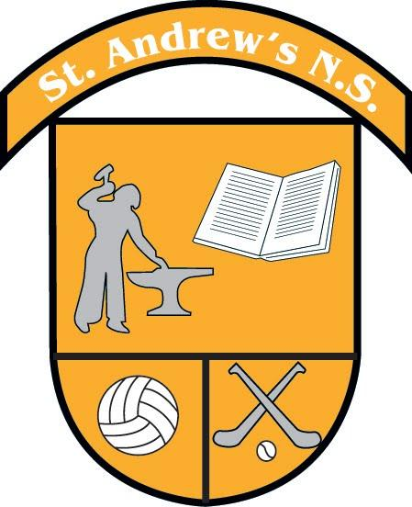
FIFTH CLASS BOOK LIST 2022 - 2023
Items which should be purchased and brought to school on Day One
(all other books will be provided through our Book Rental Scheme)

Subject | Book Title(s) | Publisher
English | Mrs. Murphy's 5th Class Copy (Cursive)  Over the Moon Skills Book (5th Class)  My Spelling Workbook F | BCM Gill  Prim Ed
Gaeilge | Foclóir - Eagrán Nua (O Siochfhrada) | Edco
Maths | New Wave Mental Maths 5th Class | Prim Ed
Misc. | 1 x Homework Diary (to be bought from school)  2 x A4 Hardback copies  6 x 120 page lined copies  2 x 120 page maths copies  2 x 40 page plastic display folders  1 x A4 spiral bound sketchbook  2 pencils, 2 black/blue pens & 2 red pens  Coloured pencils and markers  Pencil sharpener & eraser  30cm ruler, protractor & compass  2 glue sticks  Scientific Calculator  Tippex mouse (no liquid tippex please)
Uniform | Blue shirt  Maroon Tie  Maroon jumper/ cardigan  Grey trousers/ skirt/ pinafore  Full black shoes  School tracksuit and yellow polo shirt for PE days  All items are available from Blondelles Boutique, Ratoath  Bookhaven Quick Code an205c  When the Quick Code is keyed into the Quick Code box  on the Bookhaven home page (bookhaven.ie), the relevant  book list appears on screen.

St Andrew’s National School
SIXTH CLASS BOOK LIST 2022 - 2023
Items which should be purchased and brought to school on Day One
(all other books will be provided through our Book Rental Scheme)
Subject | Book Title(s) | Publisher
English | Mrs. Murphy's 6th Class Copy (Cursive)  Over the Moon Skills Book (5th Class)  My Spelling Workbook G | BCM Gill  Prim Ed
Maths | New Wave Mental Maths 6th Class | Prim Ed
Misc. | 1 x Homework Diary (to be bought from school)  1 x A4 spiral bound sketchbook  2 x 120 page maths copies  2 x 40 page plastic display folders  2 pencils, 2 black/blue pens & 2 red pens  Coloured pencils and markers  Pencil sharpener & eraser  30cm ruler, protractor & compass  2 glue sticks  Scientific Calculator  Tippex mouse (no liquid tippex please)
Uniform | Blue shirt  Maroon Tie  Maroon jumper/ cardigan  Grey trousers/ skirt/ pinafore  Full black shoes  School tracksuit and yellow polo shirt for PE days  All items available from Blondelles Boutique, Ratoath  Bookhaven Quick Code an206c  When the Quick Code is keyed into the Quick Code box on the Bookhaven home page (bookhaven.ie), the relevant book list appears on screen.
Keep from 5th class  (These items are in your child’s locker in school) | - Gaeilge hardback  - OTM hardback  - Arts Ed. copy  - RE Journal  - Test copy  - Backup copy  - SLT copy  - Foclóir - Eagrán Nua (O Siochfhrada)

