Maths  Mental Maths: Week 33 pages 66+ 67.  Tables: - 9 Table Toppers available in resource folder.  - On Friday ask a parent or an older sibling to ask you ten -9 questions.  Topic: Subtraction  Busy at Maths: pages: 106, 107, 108, 109, 110, 111.  Please go to Seesaw app for an additional Maths activity.  Please see home support sheet in resources. | Literacy  Please find ‘Hide and Seek’ comprehension worksheets in resources.  Please go to Seesaw app for an additional literacy activity.  Writing: Imagine that you are an astronaut in Space. Write a postcard telling me all about your mission. Please find worksheet in resources.  Spellings: Revision sheets in resources.  Oxford reader: Time Zone  https://www.oxfordowl.co.uk/api/interactives/30563.html
Gaeilge  If possible please follow instructions (resource folder) to download Bua na Cainte onto your computer.  Username: Trial Password: Trial  Téama: Siopadóireacht  Listen to one ceacht per day and try your best to say new words aloud.  Ceacht: 1 , 2, 3 & 4.  Bua na Cainte sheets are available in resource folder. | Art  Use tinfoil and coins to create your own moon.  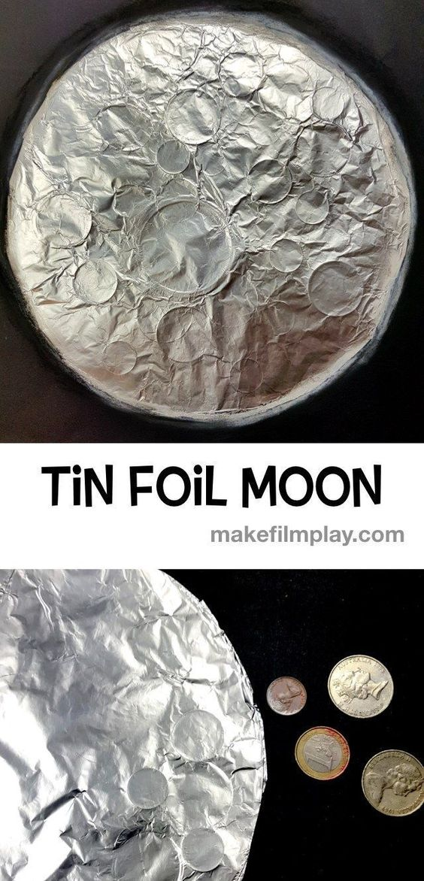
SESE
Theme: Space: Space Travel
https://www.youtube.com/watch?v=xvaEvCNZymo
https://www.youtube.com/watch?v=CbTaDOuSePk
https://www.youtube.com/watch?v=IZolorqY2AM
Please find sheets from Small World in resource folder. Read the text and answer the questions (written or orally).
Religion
Grow in Love- Theme 10 Grow in Love Lesson 2
https://app.growinlove.ie/en/user/lesson-resources/162
Username: trial@growinlove.ie password: growinlove
You have finished your Grow in Love workbook – well done!
Additional Activities
- Read a book.
- Exercise everyday https://www.youtube.com/results?search_query=pe+with+joe+wicks.
- Science experiment: https://littlebinsforlittlehands.com/popsicle-stick-catapult-kids-stem-activity/.

