St. Andrew’s N.S.

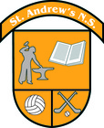

Healthy Eating
Policy

Ratified by the Board of Management 18.12.2018

Reviewed as Necessary

St. Andrew’s N.S.

Healthy Eating Policy.

Introductory Statement
This policy was developed by the staff of St. Andrew’s N.S. on 10-12-18.

Background
St. Andrew’s N.S. aims to help all those involved in our school community, children, staff and parents, to develop positive attitudes to eating and healthy living. We wish to promote ‘the personal development and wellbeing of the child and to provide a foundation for healthy living in all its aspects’. (SPHE Guidelines)
St. Andrew’s NS aims to have a clear set of guidelines concerning Healthy Eating on the premises of the school. We recognise the importance of Healthy Eating and the promotion of a healthy lifestyle. Recent research (Department of Health and Children) has highlighted disturbing trends, including an increase in childhood obesity and diabetes so therefore our policy and guidelines are both timely and critical for the health and development of children.

Policy Objectives
The overall aim of our Healthy Eating Policy is to promote a Healthy Lifestyle. Our objectives include:

- Educating children of the importance of a Balanced Diet.
- Making Children aware of the reformed Healthy Eating Food Pyramid (Healthy Ireland)
- Empower the children to make educated food choices.
- Promoting Healthy lunches as oppose to banning unhealthy snacks and treats.
- Work in close collaboration with various agencies and Government sponsored organisations in order to develop children’s awareness of food.
- Ensure each room in our school has a copy of the healthy eating food pyramid.
- The construction and maintenance of a Healthy Eating notice board. (A designated area where children can learn additional information regarding Healthy food and Diet.)
- Working alongside parents in order to appropriately educate children on the difference between a ‘good diet’ and a ‘bad diet’ and the implications that come with both.
- Enabling the children to appreciate the importance of good nutrition for growing and developing and staying healthy.
- Enabling the children to accept some personal responsibility for making wise food choices and adopting a healthy balanced diet.

The school’s vision and values in relation to Healthy Eating.

St. Andrew’s N.S. aims to empower and encourage children to live a happier, healthier life. Over a third of Irish children are overweight. Medical complications associated with being overweight are on the rise. We at St. Andrew’s NS want to make eating healthy a positive choice, not a burden.

Resources

St. Andrew’s N.S. work alongside various organisations. These organisations include:

- Healthy Ireland- Healthy Ireland provide us with Healthy Eating Food Pyramids, Health Promoting posters and booklets. “Healthy Ireland is a Government-led initiative which aims to create an Irish society where everyone can enjoy physical and mental health, and where wellbeing is valued and supported at every level of society.”
- Bord Bia- Bord Bia provide us with information booklets and posters regarding Healthy Eating and diets.
- Safe Food Ireland- Safe Food Ireland provide us with information Booklets regarding Safe food preparation and storage.
- Food Dudes: A European initiative to promote healthy eating.

Other Resources

Healthy Eating Notice Board- Our Healthy Eating Notice board is located on the Infants corridor. This notice board offers teachers the opportunity to bring children to this designated area to learn about various topics such as Allergies, Macro and Micro Nutrients and the importance of drinking water.

Our aim in St. Andrew’s N.S. is to present as much information and resource materials to the children and parents in order to promote Healthy eating.

A Healthy Lunch Box

We understand the difficulties facing parents when it comes to preparing lunches. Lunch preparation can pose many difficulties for both parents and children. We urge parents to avoid including sugary treats, chocolate bars and crisps in lunch boxes.
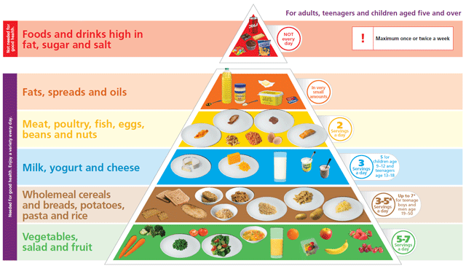
Some Healthy Food Choices may include;

Fizzy Drinks (Both Sugary and Diet Drinks) and Chewing Gum.

Fizzy Drinks and Chewing Gum are forbidden from St. Andrew’s N.S. for the obvious difficulties they present. All other items on the top section of the food pyramid may be given very occasionally as a treat when recommended by the class teacher. E.g. Christmas party/ small treat on school tour etc.

Food Allergies

In the event of an incidence of severe allergy to peanuts and mixed nuts amongst some pupils, we ask you to be vigilant in the following:
- Avoid peanuts or any other type of nut in school lunches.
- Avoid giving peanut butter sandwiches, chocolate spreads containing nuts such as Nutella, nut based breads and cereal/health bars containing nuts
Should you require clarification on this matter, please contact the class teacher.

Signed: __________________________________________
Chairperson, Board of Management

