TITANIC PROJECT

BY LOUIS CAHALAN

MAY 2020

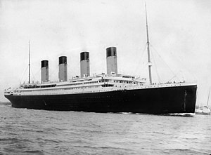

TABLE OF CONTENTS

- Construction

- Setting Sail

- Life on Board

- The Sinking

- Famous Passengers

- Interesting Facts

CONSTRUCTION

- The Titanic was built in Belfast by shipbuilding company Harland and Wolff. They started to build it in 1909 and finished in 1912 the year it set sail.

- It cost $7.3 million to make at the time.

- Eight Harland and Wolff workers died during the building of Titanic. Also, there were 28 serious accidents and 218 minor accidents recorded.

- The company was owned by Lord Pirrie, a friend of Bruce Ismay , Managing Director of the White Star Line. The Chief Designer of the Titanic was his son-in-law, Thomas Andrews.

- Titanic was constructed with sixteen watertight compartments. Each compartment had doors that were designed to close automatically if the water level rose above a certain height. The doors could also be electronically closed from the bridge. Titanic was able to stay afloat with any two compartments if the first four became flooded. Shortly after Titanic hit the iceberg it was revealed that the first six compartments were flooded.

- There were twenty-four double ended boilers and 5 single ended boilers which were housed in six boiler rooms. The double ended boilers were 20 feet long , had a diameter of 15 feet 9 inches and contained six coal burning furnaces. The single ended boilers were 11 feet 9 inches long with the same diameter and three furnaces.

Titanic being built in Harland and Wolff
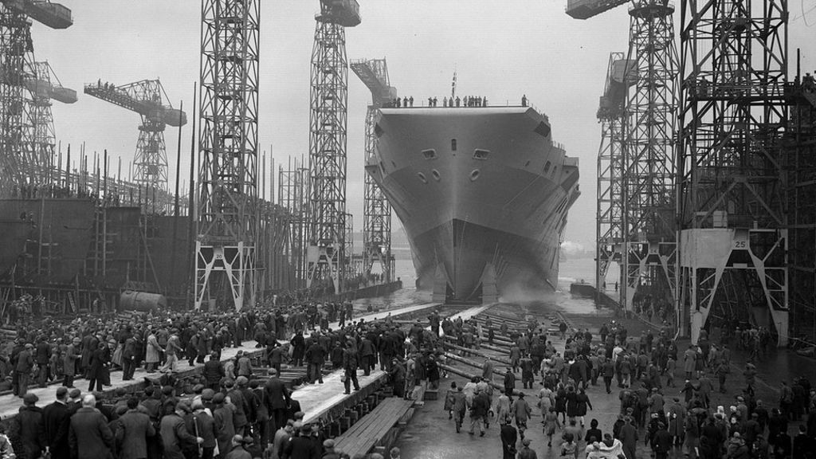
SETTING SAIL

- On the 2nd of April 1912 Titanic left Belfast and sailed 471 miles to Southampton. Titanic stayed in Southampton for 6 days before beginning its voyage to New York
Titanic in Southampton before it set sail
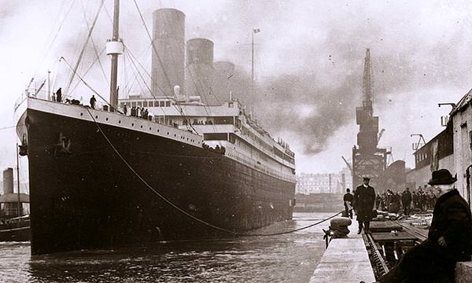
- On the 5th of April 1912 Titanic opened to the paying public for 2 days when it arrived in Southampton

- On the 10th of April 1912, Titanic sailed 84 miles from Southampton to Cherbourg in France. 22 passengers got off at Cherbourg and 284 passengers got on board.

- Then it sailed 307 miles from Cherbourg to Queenstown in Cork (now called Cobh). It got to Cobh on the 11th of April. It had to dock 2 miles off the coast. 7 Passengers got off and 120 passengers got on (mostly 3rd class passengers).

- Titanic then left Cobh to sail 2,825 miles to New York and expected the journey to take 137 hours.

- On the 14th of April - 4 days after leaving Cobh the Titanic collided with the ice-berg.
Titanic in Queenstown (Cobh)
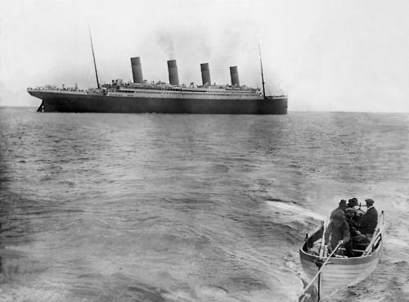

LIFE ON BOARD

Third Class Passengers
With over 1000 third class passengers on board, accommodation was basic . Cabins slept up to 10 people and were located at the noisy bottom of the ship the engine.
A third class ticket cost 13 pound.
Second Class Passengers
The titanic second class passengers enjoyed a level of luxury that rivalled that of first class on other liners. A second class ticket was 60 pound. Titanic was also the first ship to have an electric elevator for second class passengers. The following passengers are the most well known second class travellers were Lawrence Beesley , Eva hart , juozas mountvila , Thomas Byles and Charles Aldworth.
First Class Passengers
A first class ticket would cost up to 150 pound . John Jacob Astor was the richest man on the titanic . He was carrying 100 thousand pounds in his pockets when he was found dead.
One major pastime was walking and admiring the view of the sea. Lots of people swam in the pool mostly kids while the moms relaxed, lots of men went to the gym to past there time while others just relaxed in their rooms. Lots of people past the time by doing the sinking drills. Lots of kids played shuffleboard , Cricket and tennis. There was also lots of other board games such as chess , dominos and card games off all kinds .
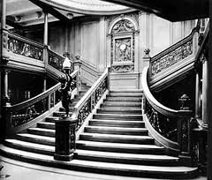

THE SINKING
- The iceberg was spotted at 11.40pm on April 14, 1912. The iceberg was around 100 feet tall and came from a glacier in Greenland. Just 37 seconds passed between the sighting of the iceberg and the collision.
- Edward Smith, the ship’s captain, went down with the vessel. 27. The ship received six warnings about icebergs during the voyage.
- A lifeboat drill, scheduled for April 14, was cancelled.
- The ship broke in two at around 2.20am on April 15. The temperature would have been -2°C – few would have survived longer than 15 minutes in the water.
- Over 1,500 people died
- Musicians played for two hours and five minutes as the ship sank.
- The SS Californian was criticised for ignoring the Titanic’s distress signals. She was sunk herself three years later by a German submarine.
- The RMS Carpathia arrived at 4am and transported the survivors to New York. 40,000 greeted its arrival.
- Only 306 bodies were found. The dead were taken to Halifax, Nova Scotia. Its Maritime Museum has a dedicated section that includes a deckchair recovered from the wreck, mortuary bags, and the shoes of an unknown victim.
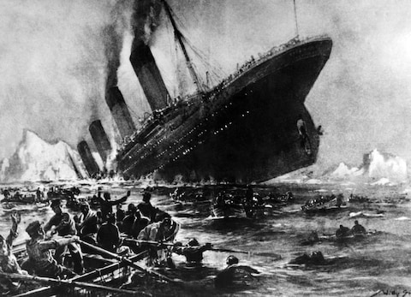

FAMOUS PASSENGERS
Some of the ship's most famous passengers included a top fashion designer, one of the wealthiest men in the world, and a famous British countess.
These are some of the most famous;
- John Jacob Astor – He was the richest man in the world
- Margaret Brown – She is famous for making the lifeboat go back to rescue people from the water
- Isidor and Ida Straus – They co-owned Macy’s Department Store
- Thomas Andrews – The designer of the Titanic
- J Bruce Ismay – He was over the White Star Shipping company. He got into one of the lifeboats and he was called a coward for the rest of his life.
- Millvina Dean – She was the youngest survivor and was only 2 months when it sunk.
- The Musicians – They could have made it to a lifeboat but chose to stay on board and play music for passengers to try and keep them calm. They were called the bravest people on the boat that night.
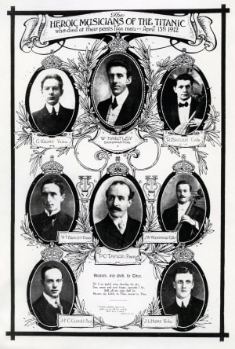
INTERESTING FACTS

- Building on the Titanic began on 31 March 1909; it was finished three years later.

- The Titanic was built in Belfast, Northern Ireland.

- The Titanic’s official name was the RMS Titanic (RMS stood for Royal Mail Steamer).

- In 1912 the Titanic was the largest man-made moveable object ever built.

- The famous ship was 92.5 feet wide, 175 feet high and 882 feet long – bigger than 3 football fields put together!

- A huge ship requires a lot of staff – the Titanic had a crew of around 900 people!

- On its maiden voyage, the Titanic collided with an iceberg and sank on April 15, 1912. Over 1500 people died.

- The Titanic was a luxury passenger liner that carried some of world’s richest people.

- The first voyage the famous ship was due to take was from Southampton to New York.

- The Titanic left Southampton on April 10, 1912 and stopped in France and Ireland before heading west to New York.

- 29 July 1908
The design for the Titanic is approved
- 31 March 1909
Building on the Titanic begins
- 31 May 1911
The hull of the Titanic is successfully launched
- 31 March 1912
The Titanic is completed
- 3 April 1912
The Titanic arrives in Southampton
- 10 April 1912
The Titanic begins her maiden voyage
- 11 April 1912
The Titanic reaches Queenstown, Ireland
- 14 April 1912
- The Titanic hits an iceberg. In the early hours of 15 April the huge ship sank into the sea.

