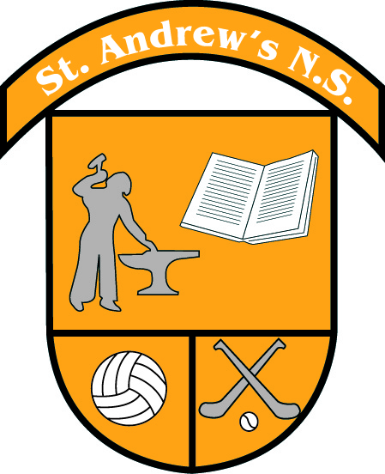
St Andrew’s National School
Curragha, Co. Meath

Tel No: 01-8351528 Email:office@standrewscurragha.com
Web: www.standrewscurragha.com

November Newsletter
Cumann na mBunscol Victory
Congratulations to our school team who won the Cumann na mBunscol Division 4 Cup In an absolutely heart stopping final. We are so proud of every single one of you! Thank you to teachers Ms. Ronan and Ms. Kinsella and mentors John McDermott and Paddy Sweeney. Thank you to Swan’s Pub who hosted the winning team and their many supporters after the match. Thank you to the PA for organising the delicious pizza for all the children.

Cross Country Championships
Congratulations to our U-11 Girls, U-13 Boys and U-13 Girls who brought home three county titles from Fairyhouse on Wednesday 22nd of November. Our U-11 Boys’ team ran a great race too with admirable individual performances/ Well done to all the runners and their commitment to training this year.

Team Hope Christmas Shoe Box Appeal
We took part in the Team Hope Christmas Shoe Box Appeal and collected 100 boxes in total. These much appreciated boxes will be sent to children affected by poverty in 12 countries across Africa and Eastern Europe this Christmas. Well done to all the families who took part.

Zumba
As part of the Dance strand in our P.E. curriculum, the children are currently enjoying 7 weeks of Zumba with Marta.

Science Week 2023
Science Week 2023 saw us engage in many exciting activiites. On Tuesday, November 14th we were visited by two scientists from UCD who showed us how materials react together. We created rockets using baking soda and lava lamps using vinegar. 5th and 6th also learned how to extract DNA from raspberries! On Wednesday, November 15th we were visited by an ecologist from the Irish Peatland Conservation Council and we learned about biodiversity. We also made a 'Bog in a Bottle'. On Friday, November 17th we had a Super Science Quiz in the hall. We learned a lot, while having some great fun too!

Parent-Teacher Meetings
Thank you to all the parents who attended the meetings with the class teachers this month. It was lovely to hear such positivity along the corridor.

Kindness Week
Our Anti-Bullying Committee (ABC) organised Kindness Week this week. All classes worked on a special kindness message to share with the school. They will be published on our school website.

St. Andrew’s Day
We attended Mass with Fr. Kevin to celebrate the Feast of St. Andrew today. We learned that we are the only church in our Diocese named after St. Andrew!

Dates for your December Diary

Christmas Fair
Our annual Christmas Fair will take place this Sunday 3rd of December at 12pm in St. Andrew’s School Hall. Tickets for Santa's Grotto and Raffle Tickets are on sale at our 'Christmas Box Office' located at the school hall every morning at 9am. Our school Christmas cards, calendars and wreaths are also on sale.
Thank you to our Parents’ Association for all their hard work in preparation for the fair.

Christmas Performances
3rd, 4th, 5th and 6th class will present the Christmas Liturgy on Tuesday 12th of December in St. Andrew’s Church at 7.30pm. Everyone is welcome to attend.
Junior & Senior Infants class will perform the Nativity for their parents in the school on Friday 15th of December at 12.30pm.
1st and 2nd class will perform ‘It’s a Party’ for their parents in the school on Friday 15th of December at 1.30pm.

Christmas Pantomimes
- 3rd, 4th, 5th & 6th class will attend ‘Sleeping Beauty’ in the Mill Theatre, Dundrum on Friday 8th of December.
- Junior Infants to 2nd class will go to see ‘Elfie Saves Christmas’ in the Venue Theatre, Ratoath on Thursday 21st of December.
- Our Parents’ Association has contributed to the cost of the pantomime and bus leaving the price at €10 per child. An Aladdin link will be emailed to you for payment.

Christmas Carols at Kilbrew
Ms Horgan will take a choral group to Kilbrew Nursing Home to sing Christmas songs for the residents on Tuesday 19th of December. Senior School children will send individual Christmas letters to the residents too.

Christmas Jumper Day
We will hold our annual Christmas Jumper Fundraiser for St. Vincent de Paul Society on Tuesday 19th of December. All pupils can wear Christmas jumpers and bring a donation on the day.

Christmas Holidays
School will close for Christmas holidays at 12 noon on Friday 22nd of December and will reopen on Monday 8th of January 2024.

