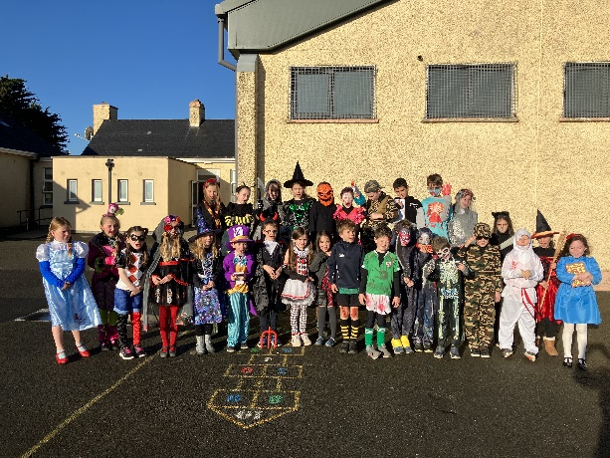

**Sport / PE **

We played basketball games and continued Gaelic football with Finn. We also played Dodge ball which is great fun! Editors Teddy, Elizabeth, Tom, Layla and Lily

**Specials Days and Birthdays **

We had a costume sale and a bake sale to raise money for our school.

We dressed up in our costumes on Halloween dress up Day.

**Aimee, Callum and Seán** celebrated their birthdays. Editors Sean, Joe , Callum, JP and Adam

**RE** 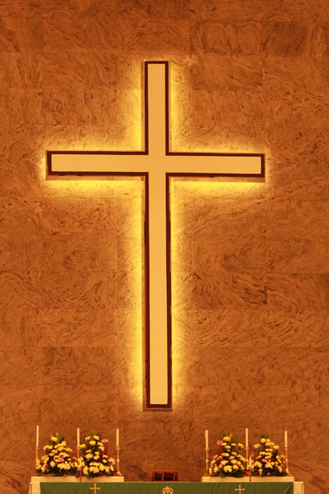

We are learning how to following Jesus and be a good friend. We are learning the Glory Be Prayer and Grace Before Meals We listened to stories and songs about Jesus. Editors Lauren, Tom, Ryan and Anna

**Visits** 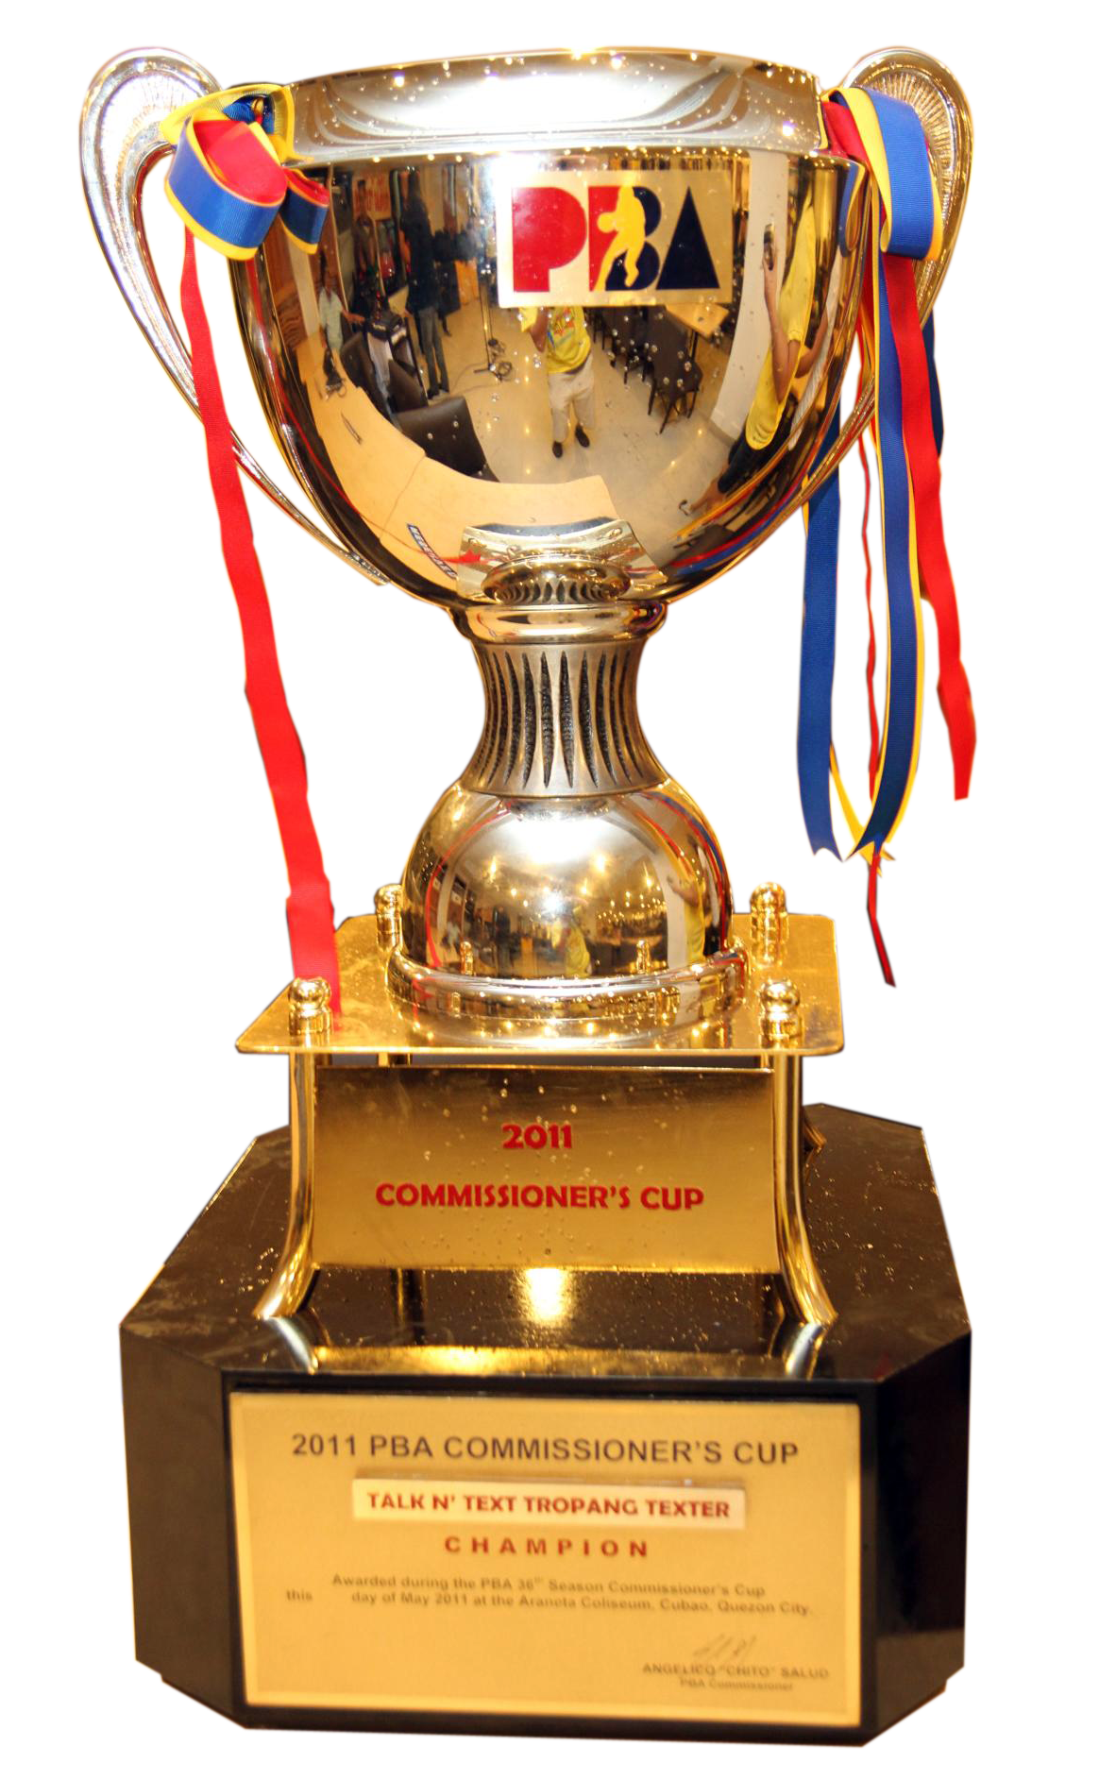

Brix for Kids visited our school and we made lego clock towers.

We welcomed Seán to Ist Class and are delighted that he has settled in so well. Editors Luke, Ava, Saoirse and Hugo

**SESE** 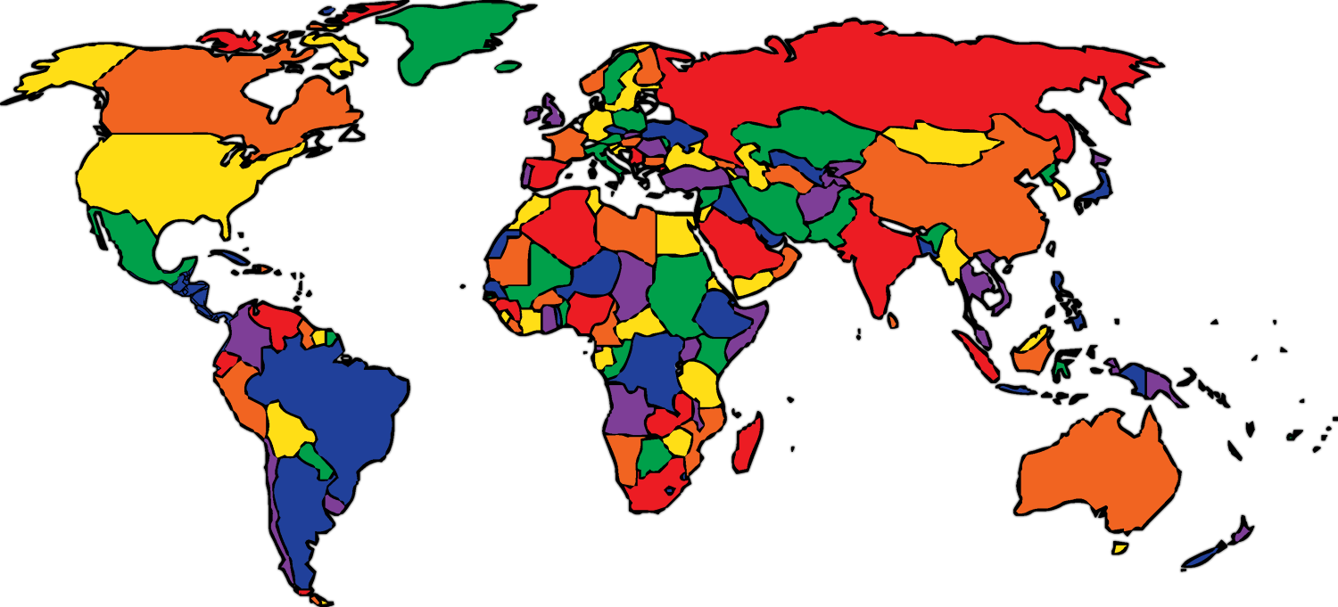

We learned about Forces and Pushes and pulls. We explored different types of homes and food around the world and discussed Halloween traditions and customs. Editors Jude, Noah, Evan and Charlie.

**Arts** 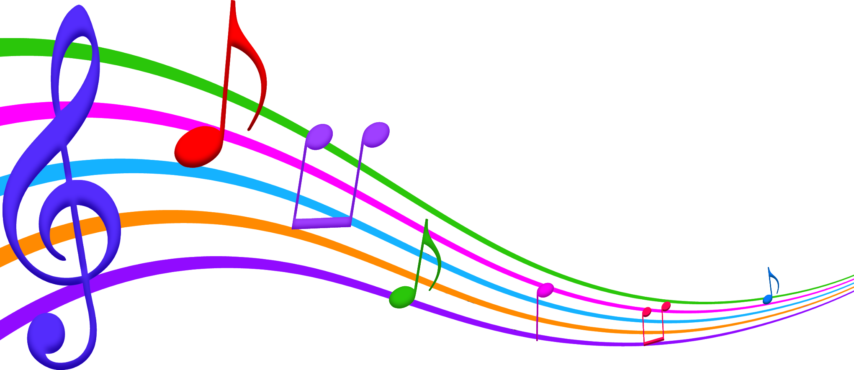

We had a super zoom call with illustrator and author Alan Nolan. He taught us how do draw a chicken and a scary bat. We took part a poster competition and coloured in our haunted houses. We continued Drama with Suzanne, learned to play the glockenspiel and learned the songs The Moon, The Skeleton Song and Witches Brew

Editors Jamie, Elle, Aimee and Isla

**English**

We shared news. We learned lots about Outer Space by reading our story from Over The Moon. We wrote reports about animals and on how to spot a witch. We read an excerpt from the Roald Dahl’s The Witches and we continued reading our class book Charlie and the Chocolate Factory. Editors Elizabeth, Teddy, Lilly, Layla and Tom O’C

**Maths** 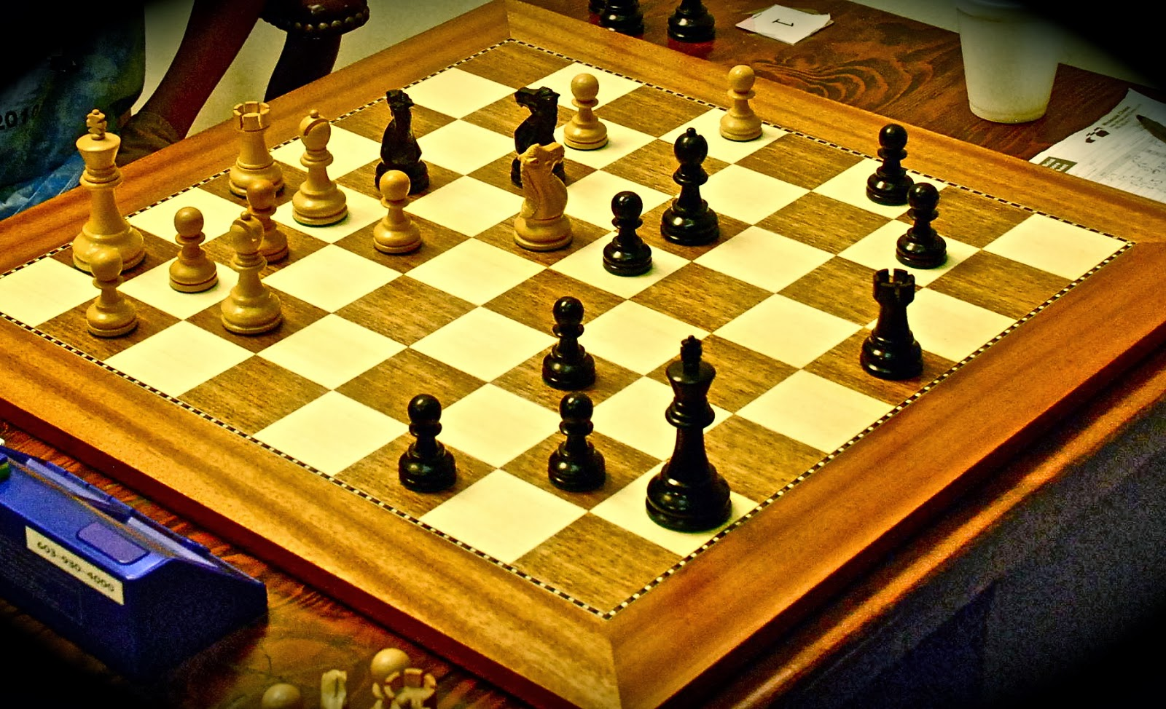

We had lots of fun in Maths this month. We took part in Maths Week and activities like the Escape Room, Brix for kids and Manga High. Congratulations to Orlaith, Elizabeth, Ryan and Callum who were on the winning team. We also learned the Number Cruncher song which taught us about odd and even numbers and made Shape Monsters. Editors Olivia, Orlaith, Sophie and Nancy.

**Gaeilge**

D’fhoghlaimíomar stór focal agus frásaí bunaithe ar an scoil agus Oiche Shamhna. Chanamar amhráin agus d’aithris muid dánta. Bhí craic agus ceol againn.