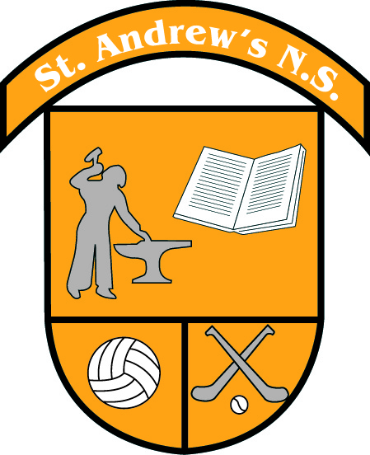
St Andrew’s National School
Curragha, Ashbourne,
Co Meath

Tel No: 01-8351528 Email:office@standrewscurragha.com
Web: www.standrewscurragha.com

26th of October 2023
Dear Parents,

As we approach our October mid-term break, I would like to highlight some of this month’s activities.

October 2023

CumannnamBunscol Success
Congratulations to our boys’ team who have qualified for the CumannnamBunscol semi-finals. We are very proud of both the boys’ and girls’ performances in the competition to date.

Brother Cross Country
The Brother Cross Country event took place for 3rd to 6th class on October 4th in Trinity Sports Grounds, Santry. Congratulations to all our athletes especially Anna May Keogh in 5th class who took first place overall.

Children’s Book Festival
Junior & Senior Infants attended a Music Workshop in Ashbourne Library on 9th of October. A great morning’s fun was had by all of the children.

Maths Week 2023
Maths Week took place from 14th to 22nd October. All children in the school completed daily maths challenges in their classes from problem solving, online games, chess, to card games and maths trails. We had a whole school Maths Escape Room activity to conclude Maths week with the Red Team led by Aoibhinn and Aoibhe coming out as winners.Childrenwere given their Manga High logins to play maths games at home throughout the week.

National Harp Day 2023
LánaCruite or Harp Day 2023 took place on Saturday 21st October. We celebrated our national instrument and emblem in school on Friday 20th of October. We are very lucky to have a harpist in 4th class in school. Róisin brought in her impressive harp on Friday to play for all our classes. All pupils completed activities about the harp. Local harpist Fiona Gryson also visited the school and played some beautiful pieces for us.

TV Appearance
2nd class appeared on Virgin Media One’s Ireland AM with Deric O’Hartigan on Tuesday 24th of October. They were invited to Emerald Park to showcase this year’s Tricky Trail. All the boys and girls did a great job representing our school.

Nature Walk
Junior and Senior Infants donned their wellies and went on a nature walk around Curragha on Tuesday 24th to see all the signs of autumn.

Anti-bullying Committee
A new Anti-Bullying Committee has been elected from 5th and 6th class. We look forward to a busy year promoting positive behaviours throughout the school. Check out their photo on our school website.

Amber Committee
A new Amber Committee has been elected from 3rd and 4th class. This group will lead the Amber Flag initiative in our school this year. Check out their photo on our school website.
Hero in the Hallway
Our fortnightly Hero in the Hallway initiative is up and running. Teachers and pupils nominate classmates for an act of kindness and the pupil chosen receives a certificate and wears our Hero in the Hallway badge every day for the two weeks!

Daffodil Challenge 2024
Junior and Senior Infants together with their Buddies from 5th and 6th class planted daffodil bulbs in our school garden this week. When in bloom, we will cut and sell them with all proceeds going to The Irish Cancer Society.

New Parents Association
We welcome our new Parents’ Association Committee members, Aoife Egan (Chairperson), Emer Bourke (Secretary) and Lora Mooney (Treasurer). Thank you to the class representatives who will continue to support the committee in organising and running events.

Halloween Bake Sale
The Parents Association will hold our annual Bake Sale in the school hall tomorrow at 1.45pm. Baked goods and treats can be dropped off at the school hall at 9am or throughout the morning. Raffle tickets will be on sale on the day. All welcome!

Coming up after mid-term…..

Homework Club and Club Francais
Homework Club and Club Francais will resume the week beginning 6th of November.

Team Hope Christmas Shoe Box Appeal
Once again we are taking part in the Team Hope Christmas Shoe Box Appeal. These much appreciated boxes will be sent to children affected by poverty in 12 countries across Africa and Eastern Europe this Christmas. An information leaflet will be sent home today with your child. Completed Shoeboxes will be collected from the school on Wednesday 8th of November.

Zumba
As part of the Dance strand in our P.E. curriculum, the children will have 7 weeks of Zumba with Marta starting on 8th of November. The cost of this activity will be €8. An Aladdin payment link has been emailed to you.

Science Week 2023
Science Week will take place from 12th to 19th November 2023. Children will take part in a Strawberry DNA Workshop on Tuesday 14th and a Bog of Allen workshop investigating peatland education, conservation and research on Wednesday 15th. The ever popular Science Dome will visit our school on Thursday 16th. The cost of this activity will be €5 per child. An Aladdin payment link will be emailed to you. We will have a whole school Super Science Quiz on Friday 17th to conclude an exciting Science Week.

Parent-Teacher Meetings
Parent teacher meetings will take place during the last two weeks in November. You will be sent an assigned time by your child’s class teacher after Halloween. If alternative times are requested, we will do our best to facilitate you.

Board of Management Parent Representatives
Since there was one nominee received for each panel, these nomineeshave been deemed to be elected. The Mothers’ Representative is Sara Shanahan (2nd class) and the Fathers’ Representative is Colin McElduff (3rd Class).

School will close tomorrow Friday 27th of October for mid-term break and will reopen on 6th of November. Enjoy a safe and happy mid-term break!

Kind regards,

___________________________
Catherine O’Connor
Principal

