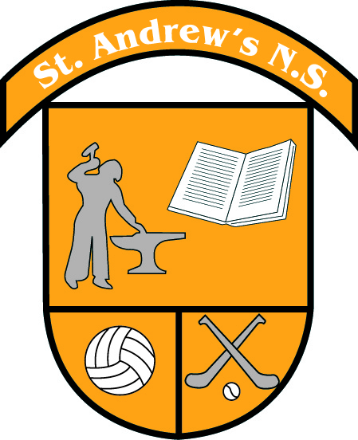

September News in St. Andrew’s N.S.

New Students
We welcome our new Junior Infants; Alannah, Alex, Conor, Darcey, Lewis, Rebeca, Robin, Ruby, Sadie, Theo and Wesley. We also welcome Abigail, Sam, Amy and Evie into other classes in our school.

New Staff
We welcome two new staff members Aoife and Karen who will join Mary as SNAs in our school.
We hope they will be very happy working in our school.

Drama
Drama Lessons with Suzanne Carey started on Friday 1st of September for 9 weeks. The Parents’ Association and Board of Management will pay for the cost of this activity.

Bodhrán
Aimee Farrell-Courtney will start bodhrán lessons with all classes on Wednesday 13th of September for 7 weeks.

Zumba
As part of the Dance strand in our P.E. curriculum, Marta Mozdzynska will teach Zumba for 7 weeks starting on Wednesday 8th of November.

Morning Training

3rd to 6th Class  Football  With Ms. Kinsella & Ms O’Connor | Tuesdays @8.30am
3rd to 6th Class  Cross Country  With Ms. Ronan | Thursdays @8.30am

School Tracksuit

Tracksuit Days
All Classes until 22nd of September | Tuesday &Thursday
All Classes from 22nd of September to Christmas | Tuesday, Wednesday &Thursday

Soccer Coaching
Past pupil and current League of Ireland player Christopher Conlan will join us as part of the FAI soccer training programme and will be coaching all children in soccer skills on Wednesday mornings from September 27th.

Cumann na mBunscol
The boys’ and girls’ Cumann na mBunscol football leagues commence next week. Thanks to Paddy Sweeney and John McDermott who are helping us with coaching and refereeing duties. Details of each match will be sent out weekly with the children, including requests for help with transporting the teams. We are very grateful to all of the parents who helped in this regard last year.

Homework Club & Club Français
Homework Club will begin for classes 1st to 6th the week beginning Monday 11th of September. Club Français started back the week of the 4th of September.

School Mass
We will have Mass for the beginning of our school year this Thursday 28th of September at 9.30am in St. Andrew’s Church. We invite our whole school community to join us.

Garda Band
On Friday 29th of September, the Garda Band will perform in the school hall at 11.15am. You are all welcome to join us for a morning of music.

Confirmation 2024
Pupils in 5th and 6th class will receive the Sacrament of Confirmation on Friday 23rd of February at 3pm in St. Andrew’s Church.

First Confession
Children in 2nd class will receive the Sacrament of Penance on 28th of February at 7.30pm in St. Andrew’s Church.

First Holy Communion
Second Class will receive their First Holy Communion on Saturday 18th of May at 10.30am in St. Andrew’s Church.

Parents Association AGM
The Parents Association will hold their AGM on Wednesday 4th of October at 8pm. The PA plays an invaluable role in working alongside school management and staff in fundraising to support the many school activities and occasions which have become in integral part of our children’s experience in school. The Halloween Bake Sale & Raffle, the Christmas Fair, Confirmation and Comunion Receptions, Table Quiz, Graduation Family Reception, Parent Coffee Mornings, Summer Discos, Sporting Fundays like the School Marathon Relay, to name but a few, are all organised by the Parents Association. For this great work to continue, I invite you to attend the AGM to meet with other parents and to help plan for the year ahead. Thank you to the outgoing committee, Jen, Trish and Donal, for their hard work and fundraising for our school.

Brother Cross Country
The Brother Cross Country event will take place for 3rd to 6th class on October 4th in Trinity Sports Grounds, Santry. Further details will follow when teams are finalised.

Maths Week 2023
Maths Week will take place from 14th to 22nd October. We will have a whole school Maths Escape Room activity and children will be given their Manga High logins to play maths games at home.

Science Week 2023
Science Week will take place from 12th to 19th November 2023. We will have a whole school Super Science Quiz and on Wednesday, November 15th all classes will visit the Bog of Allen Nature Centre, in Lullymore Co. Kildare to take part in the primary school science programme investigating peatland education, conservation and research.

Parent-Teacher Meetings
Parent teacher meetings will take place during the last two weeks in November. You will be sent an assigned time by your child’s class teacher after Halloween. If alternative times are requested, we will do our best to facilitate you.

